  - 90
 | Full Day | Half Day
 | 8 Hours CPE | 4 Hours CPE
AFWA – MEMBER | $125 | $125
NON-MEMBER | $225 | $175
Fees include continental breakfast, lunch, and afternoon snacks, as well as state fee for TN Ethics credit.
Companies with 5+ attendees receive*:
- $20 per person discount for FULL DAY
- $10 per person discount for HALF DAY
Companies with 10+ attendees receive*:
- $20 per person discount
- Plus one free registration
*Multi-discount applies to non-member rates only

REGISTRATION AND PAYMENT:
For online credit card payment and registration visit www.chattanoogaafwa.com
or
Mail completed registration form with payment made payable to “AFWA”:

Attn: Christie Jordan
1724 Colonial Way Circle
Hixson, TN 37343

Reservations not cancelled by the RSVP deadline
cannot be refunded.

Chattanooga Chapter
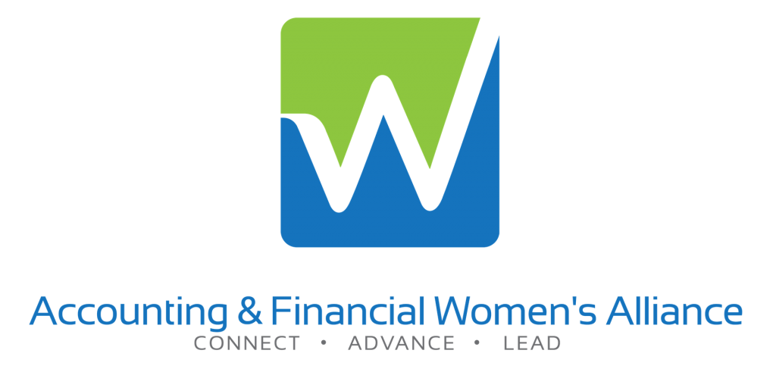

REGISTRATION FEES
RSVP & Payment Deadline
May 17, 2022


REGISTRATION FORM

Contact Name

Company Name

Mailing Address

City, State, Zip

Contact Phone Number

Contact Email Address

Number of registrations: _____________________
Attendee Names (for multiple registrations):
__________________________________
______________________________________________________________________________________________________

AGENDA

7:30 a.m. – 8:00 a.m.
Morning Registration & Breakfast
8:00 a.m. – 9:40 a.m.
Program 1 (2 Hours CPE)
Tennessee State Ethics
10:00 a.m. – 11:40 a.m.
Program 2 (2 Hours CPE)
10 Secrets Your Employees Aren’t Telling You
Working and Leading in the New Normal
11:40 a.m. – 1:00 p.m.
Lunch Buffet
1:00 p.m. – 2:40 p.m.
Program 3 (2 Hours CPE)
Fraud Update – ACFE Report to the Nations
3:00 p.m. – 4:40 p.m.
Program 4 (2 Hours CPE)
Logistics & Supply Chain Management or Where Is the Cat Food?
Networking for Career Success & Advancement

Time is allotted for morning and afternoon networking breaks with opportunities to visit our vendors!

at
The Chattanoogan Hotel
1201 South Broad Street
Chattanooga, TN 37402

is proud to present a one day
CPE Seminar

MAY 24, 2022

8 hours of CPE credit
Level: Basic
Prerequisites: None

Topics Featuring:

TN State Ethics
HR & Management Services
2022 Fraud Update – ACFE Report
Logistics & Supply Chain Management
Networking for Career Success

Plus Opportunities to Network with
Sponsors and Vendors

Company Name Here,
Otherwise Delete Box

Dr. Marilyn Helms bio, continued:

Dr. Helms holds a Doctor of Business Administration Degree (as well as an M.B.A. and B.B.A.) from the University of Memphis (TN). She is a Certified Production and Inventory Management Fellow (CPIM-F), Certified in Logistics, Transportation and Distribution Fellow (CLTD-F), a Certified Integrated Resources Manager (CIRM), and a Certified Supply Chain Professional Fellow (CSCP-F) of the American Production and Inventory Control Society (APICS).

Jason D. McCarter, CPA
Mastermelt America, LLC
PROGRAM 1 (2 Hours CPE)
Tennessee State Ethics
Field of Study: State Ethics - Technical
Learning Objective: To provide an overview of the standards for Tennessee CPA’s. This program is designed to meet the state specific ethics CPE requirement.
Jason D. McCarter is the Financial Controller for Mastermelt America in Sweetwater, TN. The Mastermelt Group of Companies specializes in the recovery of gold, silver, platinum and other precious metals from a variety of industrial sources.
Jason graduated Carson-Newman University in 2007, then joined Crowe-Horwath, LLP, where he was selected as a fellow on their Federal tax specialties service team. Since then, he served as finance director of a large faith-based non-profit organization; and at Burkhart and Company he assisted a large multinational non-profit in complete implementation of a new finance and accounting department.

Amie Haun, EMBA, CPA, CFE, CMA
Forensic & Fraud Investigations, PLLC
PROGRAM 3 (2 Hours CPE)
2022 Fraud Update: ACFE’s Report to the Nations
Field of Study: Auditing - Technical
Learning Objective: Presentation on the 12th edition of the largest global study on occupational fraud. ACFE’s Report to the Nations details the analysis of numerous cases from around the world totaling over $3 Billion. Topics include key findings, schemes, perpetrators, anti-fraud controls and detection.

Amie Haun is an Associate Lecturer for the Accounting Department at UTC. She is also a consultant at Forensic and Fraud Investigations, PLLC. Amie has over 30 years of business experience and holds a B.S. in Business Administration double concentration in Accounting & Finance, and Master’s in Public Administration from UTC, as well as an Executive MBA from Auburn University. She is a CPA, CFE, & CMA, and a member of IMA, TSCPA, AICPA, ACFE, and the FBI’s InfraGard. She serves on the local board of the Association of Certified Fraud Examiners and the Lookout Mountain Conservancy.

AFWA Meetings
Everyone is invited to attend our monthly CPE meetings on the 4th Tuesday of the month.

Check out our website regularly for updates on topics and special events!

chattanoogaafwa.com

OUR MISSION STATEMENT
To enable women in all accounting and finance fields to achieve their full potential and to contribute to their profession.

Interested in becoming a member?
For more information, visit our website at www.chattanoogaafwa.com

.
AFWA is registered with the National Association of State Board of Accountancy (NASBA) as a sponsor of Continuing Professional Education (CPE) on the National Registry of CPE Sponsors. State Boards of Accountancy have final authority in the acceptance of individual courses of CPE credit. Complaints regarding registered sponsors may be submitted to the National Registry of Sponsors through its website: www.learningmarket.org.
PROGRAM 4 (2 Hours CPE)
Logistics & Supply Chain Management or Where Is the Cat Food? (1 Hour CPE)
Field of Study: Production
Learning Objective: Review Supply Chain Management & why it is essential, including logistics & the various forms of transportation it takes for your Amazon package to reach you. Includes what happened to the supply chain during the pandemic and how lean inventory methods failed us.

Networking for Career Success & Advancement (1 Hour)
Field of Study: Personal Development
Learning Objective: To review the art & science of professional networking, how to incorporate professionalism into strategic thinking and achieving excellence.

Dr. Marilyn Helms is the Dean of the School of Business at Dalton State College, & Chair of Supply Chain Management.

PROGRAM 2 (2 Hours CPE)
10 Secrets Your Employees Aren’t Telling You (1 Hour CPE)
Field of Study: Personnel – Human Resources
Learning Objective: To provide a look at how to uncover some of the concerns your employees may not be discussing with you, & how knowing these can help improve morale and retention.

Working and Leading in the New Normal (1 Hour CPE)
Field of Study: Management Services - Technical
Learning Objective: To provide an overview of how new advancements, technology, and working from home are impacting how we now work and lead in today’s workplace.

Bethany Chaffin has over 13 years of experience helping both companies & candidates in greater Chattanooga/ North Georgia hiring market. She started with Robert Half in the administrative and customer support practice group, & is currently Practice Director for the accounting & finance contract team, focusing on both consulting & contract talent solutions. She is a Chattanooga native, and works with many area organizations helping give back to our beautiful city!
Dr. Marilyn Helms, DBA, CPIM-F
Dalton State College

Bethany Chaffin
Robert Half

